|  |  |
| --- | --- |
| **Name & ID: Chenling Zhang** | **Tutorial room location: online** |
| **Tutor: Md Sarwar Kamal** | **Date:8/25/2022** |

|  |
| --- |
| **Context of use:** *Where you are, how you are feeling, is it crowded? Were you distracted? Etc.* |
| It is afternoon, I’m now in my room. Due to the government policy to avoid the spread of COVID-9, I cannot wen to the shopping mall to try the auto-check out machine. I’m now open the video link on canvas to see the process. |

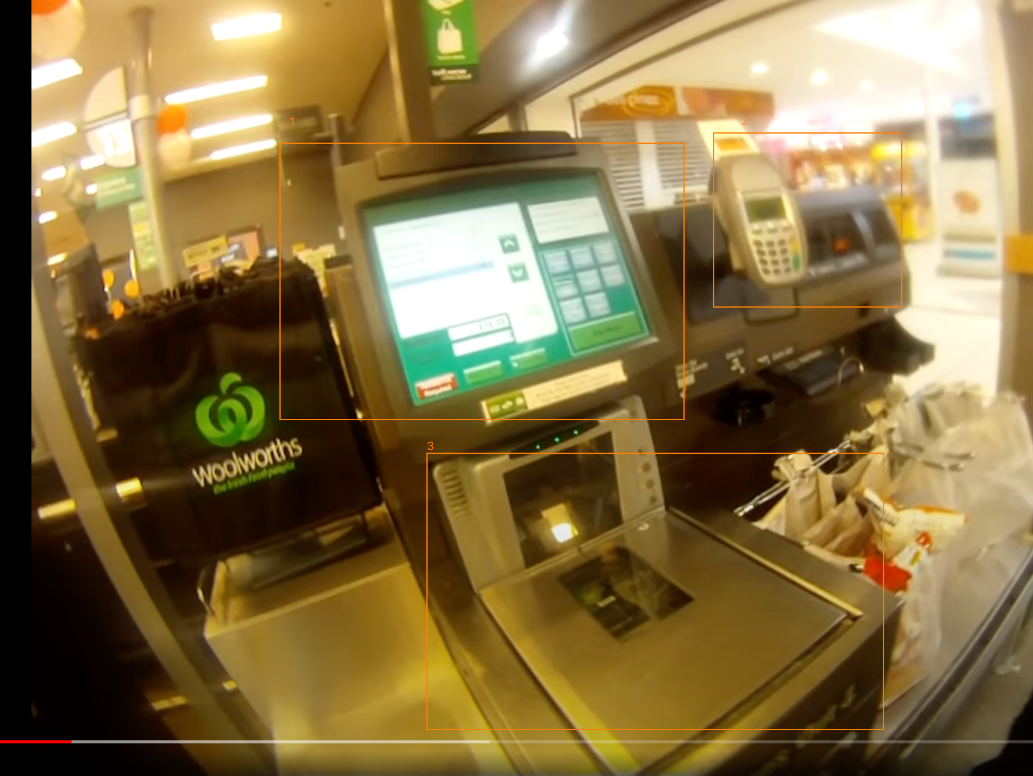

The user look at the main screen to check how to use the machine. The user instruction’s is always show on the main screen when there has no one start to use. The instruction tells user to scan the bar code which can tell the user what they will do. However, the instruction didn’t tell user’s where to find the bar code. The instruction is a signifier. When user scan the bar code on the product, the main screen will change the information. The price of the product and the product name, quality will be show on the screen, also the total amount will shows up when user start scan action. There has 3 green lights right down the screen. When these three are all green means user can continue scan product however, when they turn to red or yellow means user have to wait. These 3 light is also a kind of signifier. The information on the main screen is a kind of visibility design principle.